Project – Resources
There is a lot of inaccurate and conflicting information available – these resources are selected to help you avoid going down the wrong track.
Read the System Administration :: Debugging page on the TinyNet site!

Project – Group Component
Once each group member chooses their enhancement for individual implementation, the group is free to choose any combination. The minimum number of enhancements done by the group is 3.
Remember, maximum points for an enhancement will only be achieved when it is successfully implemented (criteria 1) and properly documented (criteria 2). Marking is points_Earned / points_Attempted, so fully completed enhancements are worth more than partially completed ones.
Documentation should be organized as a set of steps that were followed to implement the enhancement, with a focus on pitfalls and obstacles encountered and overcome – if there is a resource that is sufficient, refer to it with some critical evaluation (how complete is it? how close is their system to our system? what’s missing?) rather than copy/paste into your report.

Screenshots used to document enhancements must show the student ID of one group member in the command prompt, logfile messages, or email address.
- Login as root
- Edit /etc/HOSTNAME
Change the hostname to your student ID number and server, like this:
tp024680-mail.net-c.tinynet.edu
- Edit /etc/dnsmasq.d/cnames
Change the old name to the new name everyplace it appears
- Restart dnamasq on the Gateway
/etc/rc.d/rc.dnsmasq stop
/etc/rc.d/rc.dnsmasq start
- Reboot the host with the new name
(dnsmasq will register the new name when the host asks for an IP)

Be sure to refer to the report template for documentation requirements.
1.1 LDAP – The missing piece of our enterprise network
- Configure dovecot and squirrelmail to use LDAP
- Demonstrate by using the squirrelmail address lookup to send mail from your personal account to someone in the LDAP directory
1.2 Extended LDAP – (this is a separate enhancement, but do 1.1 first)
- Add the dc= DIT to the LDAP directory and PLA
- Demonstrate by using the squirrelmail address lookup to send mail from your personal account to someone in the dc= DIT and showing the dc= DIT users in PLA

Resources
- Configure LDAP :: Using LDAP [for 1.1]
- Configure LDAP :: Adding a DIT [for 1.2]
The squirrelmail LDAP plugin is not necessary for these enhancements

2. SUDO - when you move to Ubuntu, you will want to manage sudo!
Choose one server and
- Set up two normal users
- Allow no root login: force everyone to use sudo
- Have different color prompts for normal users and root
- Change the startup display to show a random fortune in color each time a user logs in.
- Edit /etc/issue.mytyvm to stop advertising the root password

Resources:
- Host Management :: User Accounts
- Host Management :: Prompt Color
- Standard I/O :: Ascii Art

For (a) and (c), focus on the scripts executed for a user at login. You do not need to change sshd_conf for this enhancement. For (b), create the same setup as Ubuntu.

3.1 Virtual Servers
Choose one server and
- Set up two normal users, and add directories under their home directories for their web pages and CGI scripts
- Set up a virtual server (VirtualHost) for each user in monkey.conf, change permissions on the VirtualDocumentRoot directories so users cannot access them, and add appropriate cnames to dnsmasq on the Gateway
- Set up a cron job to automatically move files from home directories to the proper VirtualDocumentRoot

Resources:
- Virtual Servers for Users in Configure Webmail :: MonkeyShines
- Creating Users in Host Management :: User Accounts

- Add cnames to your DNS for the VirtualHosts in /etc/dnsmasq.d/cnames
- Restart dnsmasq after you change the cnames
/etc/rc.d/rc.dnsmasq stop
/etc/rc.d/rc.dnsmasq start
- For (c), change the owner and group to nobody and set permissions to 700 for each of the VirtualDocumentRoot directories so they are only accessible to the system account
- NOTE: you cannot access the new VirtualServers from your host system browser, because your host system cannot use the TinyNet DNS running on the Gateway. Use the links web browser from another TinyNet VM to see your new sites.

3.2 Virtual Servers with NFS – (this is a separate enhancement, but do 5.1 first)
- Put the VirtualDocumentRoot directories (from 5.1) on a new VM which will be the server for NFS mount, and export them
- Delete the original directories and mount the exported ones
- Delete the VirtualHost users and the cron jobs on the original webserver
- Set up the VirtualHost users and run the cron jobs on the NFS server

Resources:
- Mount a Linux Shared Folder in Orientation :: Shared Folders
- Clone a new TinyNet VM and configure it as “No Role” on NetA. This will be the server that exports directories - we want it on NetA so we can upload files from Windows with WinSCP.
- If there are already files in the directories on the client, you need to copy them to the directory on the NFS server that will be exported before you mount the NFS share.
- Get the export direction right: your NFS server exports, the other server mounts.
- Get the permissions right: the Webserver can mount the NFS share ro if there are no CGI scripts that change the files.
https://www.tecmint.com/how-to-setup-nfs-server-in-linux/ is a nice reference: the packages are installed already, so skip down to Setting Up the NFS Server

4. Protocol Analysis
Use tcpflow to capture the dialog between the browser and monkey webserver when
- You access the default monkey webpage. What command line argument determines if you can or cannot recover the images from the tcpflow files?
- You access a mailbox in squirrelmail. How many requests are made? How many servers are involved?

Resources:
- Utilities :: tcpflow Examples in Practice section
- http://www.owlriver.com/tips/tcpflow-tutorial/index.php
- http://www.alphadevx.com/a/370-Running-a-network-trace-on-the-command-line-using-tcpflow
- https://www.youtube.com/watch?v=kSWznCHJfjY
- tcpflow is installed on all TinyNet machines
Be sure to clear cached files and images in your Windows browser Settings page, then start listening on the WebServer (hold Ctrl press c to stop):
Not using stunnel (http://): tcpflow -v -s -i any port any
Using stunnel (https://):: tcpflow -v -s -i any host localhost
Then use your Windows browser to connect to http://192.168.56.252/
Use Ctrl c to stop tcpflow, then start mc in a new virtual terminal on the Webserver and examine the files in /root
It helps if you know HTML, but Look For Things You Recognise (like logfiles)
For (b) go back to your Windows browser and log into Squirrelmail
You can find the tcpflow file with the ‘username’ and ‘secretkey’ you just entered!
It is interesting to watch encrypted sessions on the screen in color, but not too useful to save them to files.

5. iptables
- Add the six “Rules for things that no proper TCP stack should be processing” from the IPTables Quick Reference section -p --protocol tcp using a LOG target instead of DROP
- Save the rules to a shell script
- Use hping and multitail to show the rules are working

Resources
- Quick Reference :: iptables
- Quick Reference :: hping2
- Packet Filters :: PenTesting
- Utilities :: Multitail
Remember, shell scripts are simple:
- Type in the first rule at the command line, and check it is correct
- Use [Up Arrow] to get it back, put echo ‘at the start and’ >>file.sh at the end
- Open this file in your editor and type in #!/bin/bash as the very first line
- Save the file and set the execute permissions
- Run it from the current directory with ./file.sh

6. Syslog Server
- Reconfigure syslog on the Gateway to listen for log messages from the network. Use netstat –tulp to show it is running.
- Reconfigure syslog on the Mailhost to send root login log messages to the Gateway AND the local file /var/log/secure
- Use multitail to separate the merged logfile entries and show them in separate windows

Resources
- Orientation :: Logfiles

7. Cross-System Multitail
7.1 Use the xinetd method to set up a listener on the mailserver, and show the postfix logfiles on the Gateway and mailserver at the same time in separate multitail windows
7.2 Use the netcat method to set up a listener on the mailserver, and show the postfix logfiles on the Gateway and mailserver at the same time in separate multitail windows
(7.1 and 7.2 are separate enhancements, you can do either or both, only the starting point is different. 7.3 requires either 7.1 or 7.2 to be done first)
7.3 Modify your enhancement 7.1 or 7.2 to use the dnsmasq logfile on the gateway and the dhcpcd logfile on the mailhost instead of the postfix logfiles, and use regular expressions to select the DHCP activity for today on both servers

Resources
- Utilities :: Multitail

8. STUNNEL – Securing our enterprise network
- Setup stunnel to secure communication between all of the TinyNet servers. Use netstat –tulp to show stunnel is running on each one.
- Demonstrate a https:// connection between the host browser and the TinyNet Webserver

Resources
- SSL and SSH :: stunnel

You must use 192.168.56.252 to get the https:// connection, because this address is embedded in the server certificate

9. Basic VPN
- Setup openvpn using static keys
- Demonstrate a ping across the VPN tunnel with two sets of config files, one for tun and one for tap

Resources
- SSL and SSH :: OpenVPN
- Utilities :: xinetd
The sample configuration files are in /usr/local/etc/openvpn
All that is necessary for the enhancement is from Getting Started down to Getting Real on the OpenVPN page.
Be sure to uncomment the user directive in the sample xinetd configuration file
Recommended: Clone two new VMs (mon and fri), and use the Config.iso to configure them as “TinyNet: No Role” (use names like mon-tp0110 and fri-tp0110)
=OR= use the mailhost and the ldap server
The VPN bypasses the gateway, but your hosts still rely on DHCP for their primary IP address so it needs to be running

10. Compile and Install
- Setup a VM using the TinyNet-gcc image
- Compile the toilet source code and demonstrate using shell scripts

Resources:
- Extensions :: GCC & Make
- Standard I/O :: ASCII Art
The libcaca library must be compiled before toilet can be compiled.
Instructions for modifying the SlaxBuild script are on the site.

Remember, shell scripts are simple:
- Create an empty script with echo ‘#!/bin/bash’ >file.sh
- Open this file in your editor and type in commands exactly as you would type them on the command line
- Save the file and set the execute permissions
- Run it from the current directory with ./file.sh

Special Recommendations for Ethical Hacking

11. Migrate to Net-R
- Complete the Net-R Basic Setup: Domserv and one Net-R host
- Clone and reconfigure your TinyNet servers as Net-R servers
(NOT the gateway – the Net-R Domserv takes on that role)
- Reconfigure DNSMASQ to hand out static addresses to servers rather than dynamic ones

Resources
- Extensions :: Breaking Bad :: Setup
- /etc/dnsmasq.conf
- /var/net-r
For (c) take note that the DomServ uses a single /etc/dnsmasq.conf file instead of a directory with several “include files” like the Tinynet Gateway

12. Net-R Traffic
- Complete the Net-R Basic Setup: Domserv and two Net-R hosts
- Setup syslog on the Domserv to listen for log messages with Facility LPR and Priority Notice and save them to a particular file
- Modify the automatic traffic generation scripts on both Net-R hosts to send log messages to the Domserv

Resources:
- Extensions :: Breaking Bad:: Generating Traffic
- Orientation :: Logfiles

13. Port Knock
- Use the Netcat and Named Pipes technique to set up a reverse shell
- Use knockd and hping2 to control availability (activate/deactivate)

Resources
- Extensions :: Breaking Bad:: Remote / Reverse Shells
- knockd man page
- /usr/local/share/doc/knockd-README
- /etc/knockd.conf

Net-R Traffic Generation

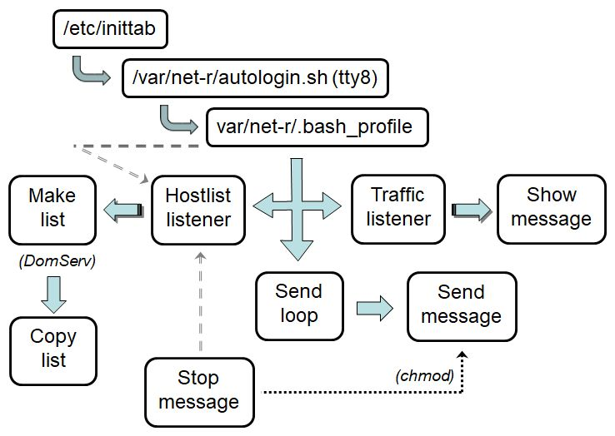
Net-R Traffic Generation

